Society for Humanitarian Archaeological Research and Exploration (S.H.A.R.E.)

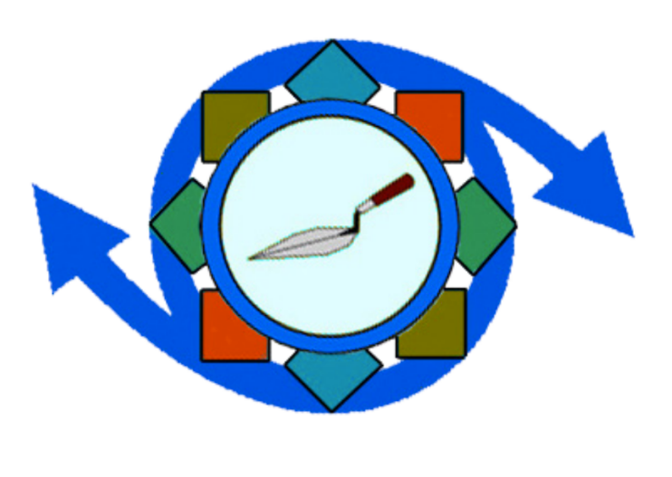
SHARE is a non-profit organization made up of students, professors, members of government, industry, and everyday people who believe in the intrinsic value of archaeological research, its relevance to modern political discourse, and its potential as a transformative power in ethnic and territorial conflicts.
*SHARE is a nonprofit under United States Internal Revenue Code 26 U.S.C. 501(c)(3).

Please print:
First Name_________________________Last Name____________________________
Address_________________________________City/State/Zip____________________
Telephone #_________________________Email Address________________________
Date of Birth_______MM/DD/YY__________Gender ___________________________
Physical Limitations: No Yes (Please Explain)_______________________________
Education (highest level completed)
Grades 1-5 6-9 11-12 College Graduate School Technical/Vocational
Current school/work______________________________________________________
Explain your interest in SHARE’s volunteer opportunities:
________________________________________________________________________
________________________________________________________________________
List your top two areas of interests:
1.______________________________________________________________________
2.______________________________________________________________________
Skills Expert Can Teach Amateur Languages Beginner Intermediate Fluent
1.___________________________________1.__________________________________
2.___________________________________2.__________________________________
3.___________________________________3.__________________________________
In an emergency, notify:
First Name____________________________Last Name__________________________
Address_________________________________________________________________
City/State/Zip_________________________Telephone___________________________
Volunteers hereby agree to serve any client who is assigned regardless of race, sex, creed or national origin.
__________________________ ________________________ ____________________
(Signature/Volunteer) (Signature/Staff) (Date)

General Media Release

The Society for Humanitarian Archaeological Research and Exploration (hereafter SHARE) develops promotional materials showing academic opportunities and activities that make up the SHARE experience, and uses such materials (“SHARE Materials”) to promote and educate the public about SHARE programs.
Please review the Media Release below. Assuming you are comfortable with its provisions, print and sign your name where indicated and provide your contact information and the date of signature. If you have any questions about this form, please contact us at info@archshare.org. Thank you for agreeing to participate in our media development efforts.

By signing below, I agree as follows:

- I authorize the staff of SHARE and its designees (“SHARE”) to use written, photographic, video, audio or other types of materials that I submit to SHARE and/or to interview, videotape, photograph, or otherwise record me (such materials and/or recordings referred to as “Media”) for purposes of producing SHARE Materials. I understand that the Media may include my voice, image, likeness, name, and/or other recognizable features.
- I transfer to SHARE all rights, including copyrights, throughout the world, that I may have in the Media.
- I agree that SHARE will have the right to edit, copy, distribute, display, perform, and create derivative works from all or any part of the Media, in any manner or medium now known or later invented, and to authorize others to do the same.
- I agree that I am entering into this Media Release solely in exchange for the opportunity to participate in this media development effort, and that I will not be entitled to any compensation, now or in the future, in connection with the Media or SHARE Materials. I understand that although the Media may be used for SHARE Materials, there is no guarantee that it will be used or that I will appear in SHARE Materials.
- By signing below, I release SHARE from all liability and claims related to my participation in this media development effort, the Media, and SHARE materials.

__________________________ ________________________ ____________________
(Signature/Volunteer) (Signature/Staff) (Date)

